#### ****public void paint(Graphics)****

Every Java Component implements **paint(Graphics)**, which is responsible for painting that component in the Graphics context passed in the parameter. When you extend a Component (like when you write a Applet), if you want to display it differently than its superclass, you override **public void paint(Graphics)** .

#### Example of an Applet

import java.applet.*;

import java.awt.*;

public class MyApplet extends Applet

{

int height, width;

public void init()

{

height = getSize().height;

width = getSize().width;

setName("MyApplet");

}

public void **paint**(Graphics g)

{

**g.drawRoundRect**(10, 30, 120, 120, 2, 3);

}

}

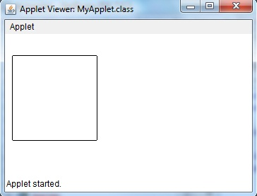

#### How to run an Applet Program

There are two ways to run an applet.

* Executing the Applet within Java-compatible web browser.
* Using an Applet viewer.

For executing an Applet in an web browser, create short **HTML file** in the same directory. Inside **body** tag of the file, include the following code.

< applet code = "MyApplet" width=400 height=400 >

< /applet >

#### Run the HTML file

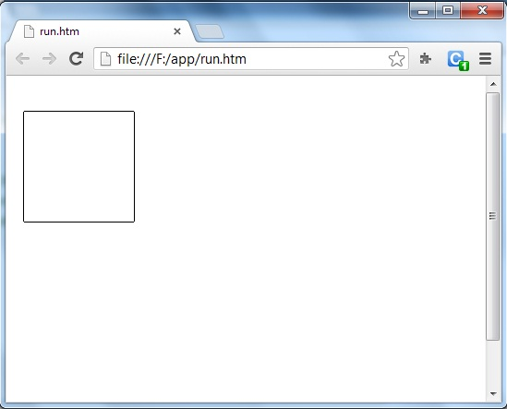

#### Running Applet using Applet Viewer(command window.)

To execute an Applet with an applet viewer, write short HTML file . If name it as **run.htm**, then the following command will run your applet program.

f:/>appletviewer run.htm

